# Managing an Agile Team

## Instructions & Template for Peer-Reviewed Assignment

# NOTE: Go to the ‘File’ menu and then use either ‘Make a copy’ or ‘Download As’ to make yourself an editable copy of this template.

# 

# What am I doing?

## Overview

For this assignment, you’ll develop a few key sections to anchor an agile team charter. If you want to see how these might function in a full charter, check out this tutorial: [Agile Team Charter](https://www.alexandercowan.com/agile-team-charters-the-basics/). *However, the idea here isn’t to complete a whole charter- just the items you see below*. you’ll answer three focal questions.

This assignment should take you 2-3 hours. If it’s taking more than that, please post to the forums about what you’re finding challenging (or what’s occupying your time).

## General Instructions

To complete your work, you can use the Microsoft Word and PowerPoint templates provided on the assignment page or the [Google Docs](https://docs.google.com/document/d/130qgBxlk3i56rkyl0V_G94qKQtmyld6AGrDuI23Aojg/) and Google Slides templates, which are here:

[Business Model Canvas](https://docs.google.com/presentation/d/1wObawm1l49FPdEDcPX65WrujmYvvy0el2HgmarmJS2M/edit#slide=id.g387605415_19)

[Corporate Innovation Canvas](https://docs.google.com/presentation/d/1XqkH42K4ncSF5Rc7ZCD9Wq_7Z0t-6XzFzKojOxyIo_E)

Also, as you go through these, you may want to delete the **Intro Note and Instructions** sections in your copy. (In Google Docs, right-click (or two-finger click on Mac) and select ‘Delete Table’.)

# 

# 

# Part 1: Positioning Statement

## Intro Note

If you’re in the specialization, I recommend picking a concept you can build up through the courses. For example, you might have an idea to solve a problem (job, desire) you’ve had or seen, or you might want to focus on something at your current job.  ***Regardless, it's most important that the idea is relatively specific (vs. perfect) and that it’s okay for you to share it with your peer reviewers.***

## Instructions & Example

|  |
| --- |
| For your product concept, just state what it does in the format you see below in ‘Assignment’. As obvious as it may seem, I find this helps with focus and collaboration- it will also help your peer reviewers better understand the balance of your assignment.  For an example, please see Appendix 1/Positioning Statement. |

## Assignment

Introduce the company whose product you’re working on with the positioning statement structured as follows [fill in the brackets]:

**For** content creators, students, and professionals **who** struggle to extract key insights from lengthy YouTube videos, **the** MindTube AI **is a** video summarization tool **that** automatically generates concise text summaries and mind maps. **Unlike** manual note-taking or traditional video transcripts, **our product** provides AI-powered, structured summaries that save time and enhance comprehension.

# Part 2: Focal Questions

## Intro Note

In Week 1, you saw how HVAC in a Hurry answered these questions and I’ve included screenshots of these as a refresher. If you want to answer them in that fashion, great. However, if you’d like to approach them in another way, that’s fine.

## 

## 1. What’s important to this business? Why? How is it measured with regard to customer/user behavior?

|  |
| --- |
| Instructions (Delete) Use ONE option below for answering these questions:   1. Use the Business Model Canvas (or Corporate Innovation Canvas) and a storyboard (optional). 2. Describe these generally using text and/or some other tool you prefer.   You’ll also see a storyboard in the example below. Feel free to include that or not. If you do, paper and pencil is 100% fine- just take a photo of whatever you did and add it to your charter doc.  For an example, please see Appendix 1/Part 2/Question #1. |

### **Answer to the Question: "What’s important to this business? Why? How is it measured with regard to customer/user behavior?"**

#### **What’s Important to This Business?**

This business values **customer engagement, user satisfaction, and product-market fit** as key factors for success. The goal is to ensure that the product/service effectively meets user needs, driving customer retention and business growth.

#### **Why?**

* **Customer-Centric Approach:** Satisfied customers are more likely to become repeat buyers and brand advocates.
* **Sustainable Growth:** Understanding user behavior helps refine marketing strategies and improve service offerings.
* **Competitive Advantage:** Adapting to customer feedback ensures the business remains relevant in a dynamic market.

#### **How is it Measured?**

The business can measure customer/user behavior using the following key metrics:

1. **Customer Retention Rate (CRR):** Measures how many customers continue to use the service over time.
2. **Net Promoter Score (NPS):** Gauges customer satisfaction and likelihood of recommending the product/service.
3. **Conversion Rate:** Tracks how many visitors turn into paying customers.
4. **User Engagement Metrics:** Includes time spent on the platform, feature usage, and interaction frequency.
5. **Customer Feedback & Reviews:** Surveys, ratings, and direct customer feedback provide qualitative insights.

To present this information visually, the **Business Model Canvas** can be used to outline value propositions, customer relationships, and revenue streams. Additionally, a **storyboard** can illustrate user journeys and common pain points.

## 

## 2. For which problem scenarios/jobs-to-be-done should we test new propositions?

|  |
| --- |
| Instructions (Delete) The idea here is to do two things to help your team adopt a problem/job-centric view of what they do and what success means for them.  First, consider which underlying Problem Scenarios or Jobs-to-be-Done your team works on. How do they relate to the company’s Value Propositions and/or Key Activities?  Note: If you’ve already done JTBD/PS for one of the other courses in a specialization, it’s 100% OK to reuse them here- just make sure you’re thinking about how they relate to the overall objective of the charter.  For an example, please see Appendix 1/Part 2/Question #2. |

[Fill out the table below.]

|  |  |  |
| --- | --- | --- |
| **Problem Scenario/Job-to-be-Done** | **Your Value Proposition** | **Notes (optional)** |
| [INSERT- What underlying problems/needs/jobs exist for your target customer?] | [INSERT- What are you delivering for the Problem Scenarios that causes the customer to buy (or user to engage)?] | [INSERT- OPTIONAL] |
| Professionals and students need a quick way to capture key insights from educational or training videos. | Offer structured summaries with timestamps and key points to improve learning efficiency. | Consider supporting multiple languages. |
| Content creators and marketers need insights on trending topics without watching entire videos. | Deliver trend analysis and highlight extraction for efficient content ideation. | Add keyword and sentiment analysis features. |

## 

## 3. How will we define and measure success?

|  |
| --- |
| Instructions (Delete) For the Problem Scenarios your team works on, how do you measure success? Define progress however you see fit in this section, but be clear about:  a) How your definition of success relates to your selected Problem Scenario(s) and Value Proposition  b) How you’ll measure success  For an example, please see Appendix 1/Part 2/Question #3. |

- Definition of Success:

- Success is determined by how effectively the AI-powered tool generates accurate, concise, and structured summaries/mind maps that users find useful.

- The tool should improve comprehension, reduce video-watching time, and enhance content extraction for different user groups.

- Metrics for Measuring Success:

1. User Engagement:

- Number of active users per month.

- Average session duration and interaction rate with summaries/mind maps.

2. Accuracy & Relevance:

- User feedback scores on the usefulness and correctness of generated summaries.

- Comparison with human-generated summaries for quality assessment.

3. Adoption Rate:

- Growth in new users and retention rates.

- Percentage of returning users within a set time period.

4. Efficiency Gains:

- Reduction in time spent watching videos before getting insights.

- Surveys measuring perceived improvement in learning efficiency.

# Part 3: Team Logistics (NOT PART OF THE ASSIGNMENT)

|  |
| --- |
| Note While this is beyond the workload we find suitable for a standard peer-reviewed assignment, I wanted to show you how the above material connects with the more tactical parts of an agile team charter. If or when you plan to put this charter into use with a team, I recommend adding this material. See here for more detail on it: [Full Agile Team Charter](https://docs.google.com/document/d/167t2sw5XvxVeQIfZMcNsm2lk_FibG5MxalAkYbNmgtY).  Good news: Part 2 above, which you’re done, is the really hard part! ; ) |

# Submitting Your Assignment

Remember to upload your work in ONE document (PDF format), including your:

1. Positioning Statement
2. Focal Questions
3. Team Logistics (Optional)

# 

# Appendix 1: Reference Example

## Part 1: Positioning Statement

### Intro Note

I’ve included a positioning statement for both the enterprise as a whole and the specific (internal) product the HinH team is working. I thought this enterprise statement would help with context/relevance for the product. Including a positioning statement for the enterprise/company as a whole is optional, though.

### For the Enterprise as a Whole

For [facilities managers & business owners] who [need their heating & cooling systems managed and repaired], [HVAC in a Hurry] is a [full service heating and cooling provider] that [allows for easy and responsible management of a business’ HVAC systems]. Unlike [smaller firms], our [commitment to best practices and training allows customers to worry less and realize superior total cost of ownership for their HVAC systems].

### 

### For their Digital Platform

For [dispatchers and technicians] who [work at HVAC in a Hurry], [H-ify] is an [enterprise software solution] that [improves the HVAC repair and maintenance experience for both internal staff and customers]. Unlike [ad hoc solutions], our product [has been carefully formulated and validated against best practices and awesome customer experiences out in the field].

## Part 2: Focal Questions

### 1. What’s important to this business? Why? How is it measured with regard to customer/user behavior?

HinH’s core market is the Medium Bus. segment. Smaller companies are more expensive to service (relative to revenue) and larger firms have an in-house capability. As we work to sharpen and scale our product/market fit, this is where we currently believe we should focus.

Customers in the Medium Business segment value the ability to outsource their HVAC operation- we’re able to help them operate better while saving them money (over the long term) and taking the overhead out of planning and managing an in-house HVAC capability. Our ability to sell and deliver those Value Propositions is what currently drives profit. Specifically, this is measured by our ability to convert and retain customers in this segment to Fixed-Price Full Service Contracts (vs. As-Billed/ad hoc contracts).

We work with the Landlord segment opportunistically as a way to meet future customers. However, the overhead of interfacing between landlords and tenants as well as their more singular focus on minimizing cost makes it difficult for us to proactively manage these systems, increasing our cost and necessarily our cost to the customer.

The Small Business segment is highly opportunistic and we are considering raising rates or more rigorously screening out these accounts. They generate a disproportionate amount of overhead relative to revenue.

While there are many important customer experiences (CX), the event where we service a call from a new prospect in the Medium Business segment, deliver well, and set them up for a conversion to a Fixed-Price Full Service Contract is one of the most important.

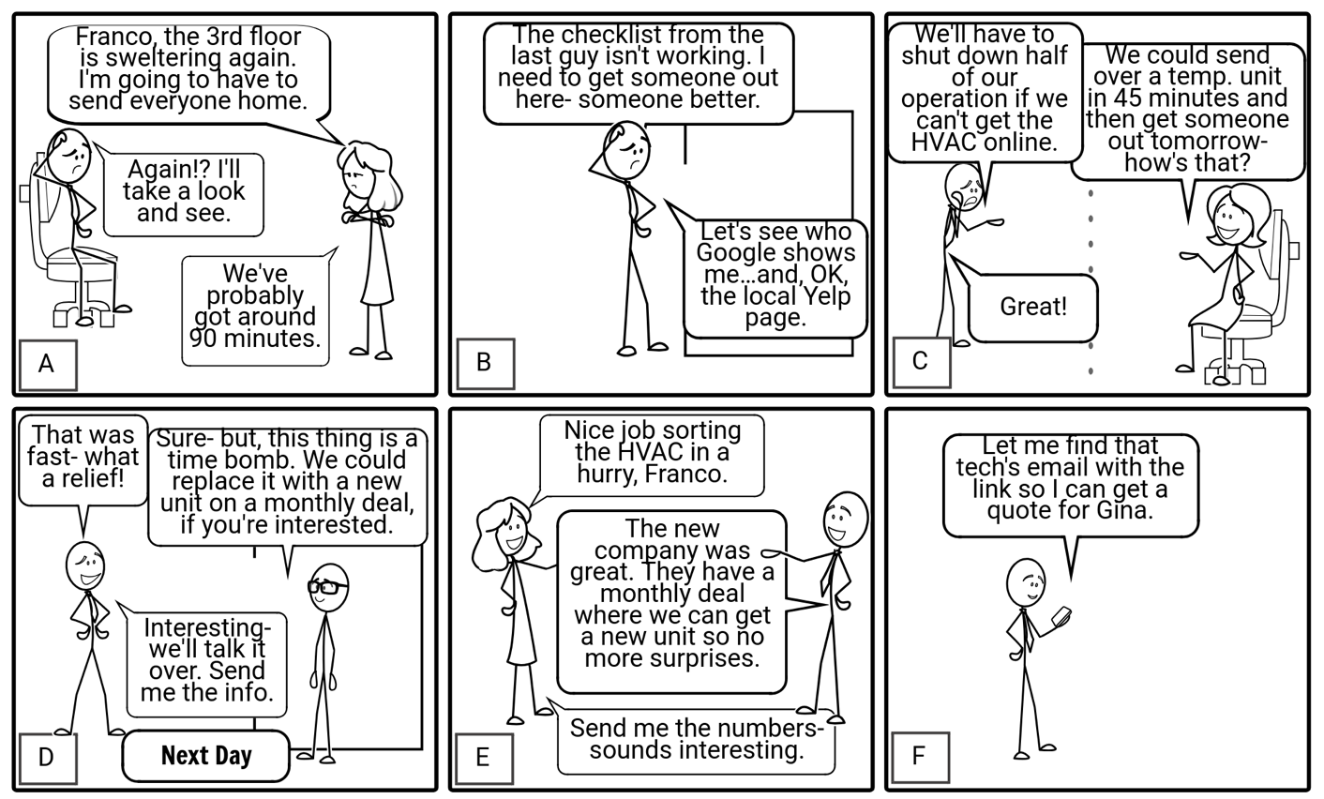

|  |  |  |
| --- | --- | --- |
| **Panel** | **Notes** | **Questions & Observations/Metrics** |
| A | The customer has an urgent issue- one that affects their core operation. The facilities manager, or whoever’s in charge of the HVAC, is charged with solving the problem. | n/a- not directly observable by us (outside of qual. research with non-customers)- but see below |
| B | The customer isn’t satisfied with their current vendor. This isn’t uncommon- even shops that do competent work underperform on equipping their customers with process to deal with maintenance, particularly urgent maintenance. We know Yelp is a popular go-to even for these larger firms when they’re acutely in need, and we’ve invested in generating the customer outcomes and feedback so that we rank well there in our key markets. | How many of these inbound calls are we getting?  Where are they coming from? Where did the customer hear about us?  Metrics:  Inbound Calls with Type ‘New Customer Inquiry’  Answer to ‘How did you hear about us?’ (part of call script and follow-up survey) |
| C | As disruptive as it sometimes is, we’ve equipped our dispatchers to qualify and address such emergencies from new customers- for example, arranging to deliver temporary units for spot cooling or heating. This allows us to sell an initial visit by an actual tech, which we also make a high priority. | How many of the above calls are we able to convert to a billing of some sort?  Metrics:  Inbound Calls with Type ‘New Customer Inquiry’ => Conversion to New Account with >0 revenue |
| D | Our technicians know how to solve the problem at hand, while helping the customer think ahead. This is how we deliver our core proposition of reliable, low cost, predictable management of HVAC systems. This also helps us with new customer acquisition. | How many of our new customer calls convert to another billable event after the initial issue is resolved?  How many of them convert to a Fixed-Price Full Service contract?  Metrics:  New accounts with billings after 2 weeks of first billings (to control for initial issues that took multiple visits)  Quotes for Fixed-Price Full Service Contracts for above accounts  New accounts that convert to Fixed-Price Full Service Contracts within six months after initial inquiry |
| E | We have leave-behinds and follow-up’s to equip our point of contact to ‘sell’ the conversion to HinH. | (see above) |
| F | From here, we measure the sales funnel through relatively conventional CRM/SFA metrics relative to a qualified lead. | (see above) |

### 

### 2. For which problem scenarios/jobs-to-be-done should we test new propositions?

Currently, our team plans to focus on the JTBD/PS’ below. The first JTBD, deciding on leads to call, is actually at the intersection of our combined VP delivery and the Key Activity of Account and System Maintenance.We are specifically looking at how our salespeople onboard new accounts for delivery of that KA.

The second JTBD/PS relates to our Key Activity of Account and System Maintenance.

|  |  |  |
| --- | --- | --- |
| **Problem Scenario/Job-to-be-Done** | **Your Value Proposition** | **Notes (optional)** |
| Helping the HinH salespeople decide what customers to call in order to generate new sales of fixed price contracts. | If we give the salespeople a better way to decide their calls list for the day, then the salespeople will use our dashboard/tool and it will improve their sales. |  |
| Enabling HVAC technicians in the field to order replacement parts | If we automate parts lookup and ordering online, then the technicians will use it and it will improve outcomes. |  |

### 

### 3. How will we define and measure success?

We plan to measure success on our outcomes relative for the two PS/JTBD below- see notes in the second column for how we plan to do this.

|  |  |
| --- | --- |
| **Problem Scenario/Job-to-be-Done** | **Measuring Success/Outcomes** |
| Helping the HinH salespeople decide what customers to call in order to generate new sales of fixed price contracts. | How many salespeople engage with our tool, and how often? |
| Enabling HVAC technicians in the field to order replacement parts | How many orders are placed through our tool relative to total orders? |

# 

# Appendix 2: Notes on Using a Canvas for Focal Question #1

## Intro Note

Pick either the Business Model Canvas or Corporate Innovation Canvas and complete the following elements for whichever canvas you chose:

|  |  |
| --- | --- |
| **Business Model Canvas:**   1. Product (or Service)/Market Fit via Customer Segments and Value Propositions 2. Customer Experience via Customer Relationships and Channels 3. Business Model Type via Key Activities, Resources, and Partners | **Corporate Innovation Canvas:**   1. Focal Customer Segments and Problem Scenarios 2. Big Innovation Goals 3. Innovation Metrics |

Note: Your work on the canvas will help you complete Part 3 of this assignment.

You can leave the remaining elements of the respective canvas blank. They’re not necessarily important for your project and you can always work on them later if the need/interest arises.

## Instructions

Fill out the canvas you have selected using the Microsoft PowerPoint templates provided on the assignment page or the Google Slides templates:

[Business Model Canvas](https://docs.google.com/presentation/d/1wObawm1l49FPdEDcPX65WrujmYvvy0el2HgmarmJS2M/edit#slide=id.g387605415_19)

[Corporate Innovation Canvas](https://docs.google.com/presentation/d/1XqkH42K4ncSF5Rc7ZCD9Wq_7Z0t-6XzFzKojOxyIo_E)

### 

### Adding Slides to the Charter

Regardless of whether you’re using the Word/PowerPoint templates or the Google Docs templates, you’ll copy and paste the applicable slides from the left-side Slides Pane into your Agile Team Charter doc:

